Health & Safety using a computer

It is important to use good health and safety practices while working at your computer. Constant use of the mouse and repetitive keyboard activity can contribute to injuries associated with repetitive strain injury (RSI)
1. | Setting up your workstation | Adjust the position of:  - the screen so that it is at eye level and directly in front of you and adjust the brightness or contrast to make it easier to use  - the keyboard so that you have space of about 100mm in front of it. Some people like to use a wrist rest to keep their wrists straight and level with the keys  - the mouse needs to be as close to you as possible  Make sure that you have space to use your mouse easily and to rest your wrists in front of the keyboard when you are not typing.
2.  Seating | 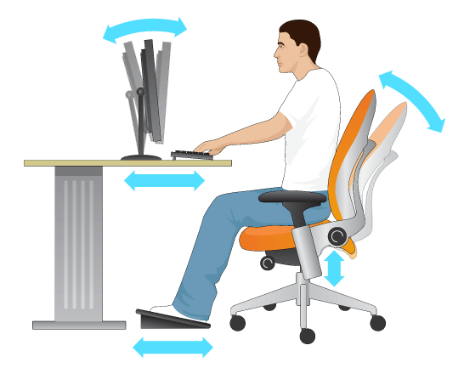 | Adjust your chair so that:  - your lower back is properly supported  - your knees are level with your hips  - your wrists and forearms are straight and level with the floor  - your elbows are by the side of your body so that the arm forms an L-shape at the elbow joint  - your feet should be flat on the floor – you may need a footrest
3. | Take regular breaks | Long spells of intensive screen work should be broken up by periods of non-intensive work of a different kind.  - short, frequent breaks are more satisfactory than occasional, longer breaks. A break five minutes after twenty or thirty minutes of continuous work with the screen and keyboard is likely to be more effective than a fifteen-minute break every two hours.  - you should take your breaks away from the computer

