How to save Internet sites

When you find a web site that you might want to visit again, you can save it as a bookmark in your favourites
1. | With the web page that you want to save on your screen:  Left Click on the in the top right hand corner of the screen
2. | This will show you a list of all the existing favourites  Left Click on Add to favorites
3. | A pop up widow will appear.  Make sure the Name: is helpful  Left Click on Add | 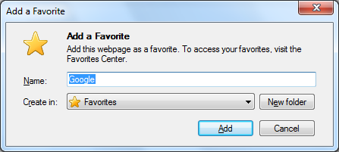
4. | To go to your favourite web site:  Left Click on the star in the top right hand corner of the screen  Your new web site will be on the list.  Left Click on the web site you want to open

